
PRESS RELEASE

In the first quarter this year, the CTIA seized 2,404 items of counterfeit merchandise priced at nearly 5 million crowns
(Report for the First Quarter of 2026)
(Prague, July 20, 2026) In the first quarter of this year, the Czech Trade Inspection Authority continued to monitor compliance with the ban on offering, selling, and storing products infringing certain intellectual property rights. It carried out 99 inspections and found breaches of the prohibition on offering for sale, selling, and storing products infringing certain intellectual property rights in 23 of those inspections, representing 23.23% of the inspections conducted.
All Regional Inspectorates of the CTIA participated in the inspection activity, which focused on inspecting compliance with the prohibition set forth in Section 8 of Act No. 634/1992 Coll., on Consumer Protection. A total of 99 inspections were carried out between January 2 and March 31, 2026. Breaches of legal regulations falling within the CTIA’s supervisory jurisdiction were identified in 61 inspections (61.62% of the inspections carried out); of which 23 inspections revealed infringements of the prohibition on offering for sale, selling, and storing products infringing certain intellectual property rights, representing 23.23% of the inspections carried out.
Based on breaches of legal regulations identified within inspection activities, a total of 107 fines amounting to 2,107,500 CZK became final between January 2 and March 31, 2026. In direct connection with breaches of Section 8 of the Act on Consumer Protection, which prohibits the offering, sale, and storage of products infringing certain intellectual property rights, 69 fines totalling 1,766,000 CZK became final during this period.
In addition to the sanctions, a total of
2,404 counterfeit items, valued at CZK 4,915,479 based on the prices of the originals (original prices are approximate) were seized and placed beyond the reach of the parties being inspected. In accordance with Section 7b of Act No. 64/1986 Coll., on the Czech Trade Inspection Authority, the seized products were placed beyond the reach of the inspected entities. Products that do not comply with special legal regulations and for which a final decision has been made regarding their forfeiture or seizure are subsequently destroyed or used for humanitarian purposes.
In terms of product categories, intellectual property rights were most frequently infringed in the case of textile goods. Of the total number of seized products, the majority—by volume—were trademarks of Adidas, Tommy Hilfiger, Nike, the Rubik’s Cube, Lilo and Stitch, Michael Kors, Calvin Klein, and Pokémon Wizards.
The share of individual product categories in the total volume of goods seized on suspicion of infringing any intellectual property right is illustrated in the following chart:

Chart No. 1: Share of product categories in the total volume of seized goods

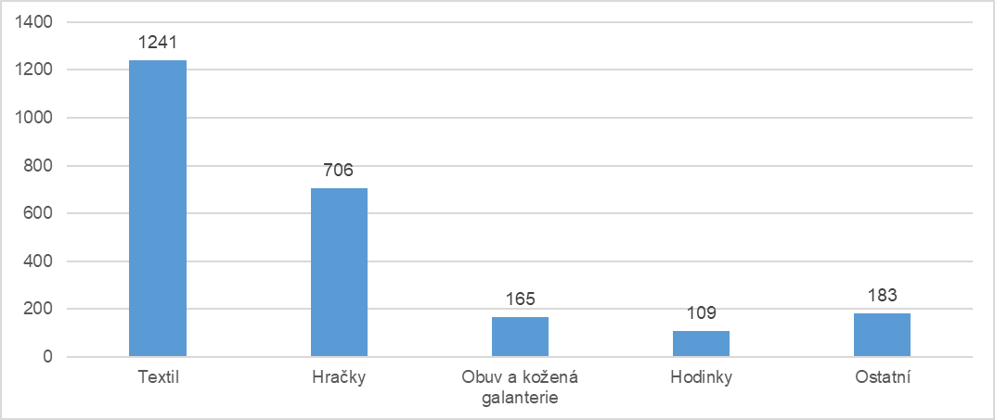

The following chart shows the share of selected trademarks in the total volume of seized products. Trademarks not included in the list appeared on fewer than 80 of the seized products.
Chart No. 2: Seized Products by Brand

